**SQL Developer Internship Documentation**

CASE Statements for Conditional Transformation

**Objective**

Use SQL CASE statements to transform and categorize data based on specified conditions.

**Project Steps:**

**1. Setup:**

Create and populate the StudentScores table with sample data:

CREATE TABLE StudentScores (

StudentID INT,

TotalScore INT,

MathScore INT,

ScienceScore INT

);

INSERT INTO StudentScores (StudentID, TotalScore, MathScore, ScienceScore)

VALUES

(1, 95, 45, 50),

(2, 85, 35, 60),

(3, 75, 40, 30),

(4, 65, 25, 20);

**2. Execution:**

I. Run the queries sequentially:

II. Grade assignment query.

III. Pass/Fail status query.

**Tasks to Perform**

1. Assign Grades Based on Total Scores

● **Goal:** Assign grades to students based on their total scores.

● **Logic:** CASE statements can categorize students' total scores into grade brackets, e.g.:

■ >= 90: A

■ >= 80: B

■ >= 70: C

■ < 70: D (Fail)

**Query:**

**SELECT StudentID, TotalScore,**

**CASE TotalScore**

**WHEN (TotalScore >= 90) THEN "A"**

**WHEN (TotalScore >= 80) THEN "B"**

**WHEN (TotalScore >= 70) THEN "C"**

**WHEN (TotalScore < 70) THEN "D(Fail)"**

**END AS TotalScore_Of_Students**

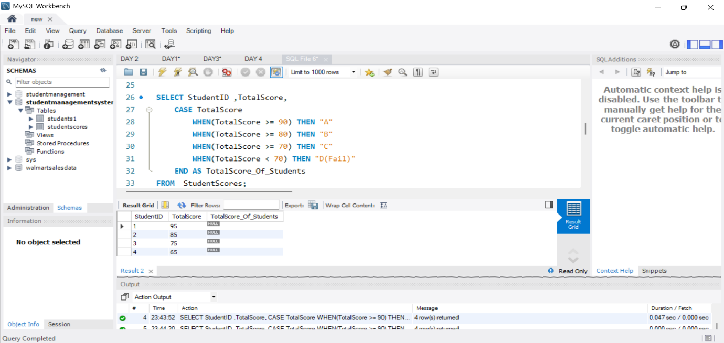**FROM StudentScores;**

2. Identify Pass/Fail Status in Specific Subjects

● **Goal:** Check if a student passed or failed in each subject based on a passing threshold.

● **Logic:** Use a CASE statement to evaluate individual subject scores:

■ Example: Pass if score ≥ 40, Fail otherwise.

**Query:**

SELECT StudentID, MathScore, ScienceScore, TotalScore,

CASE

WHEN TotalScore >= 40 THEN 'PASS'

ELSE 'FAIL'

END AS TotalScore_Status

FROM StudentScores;

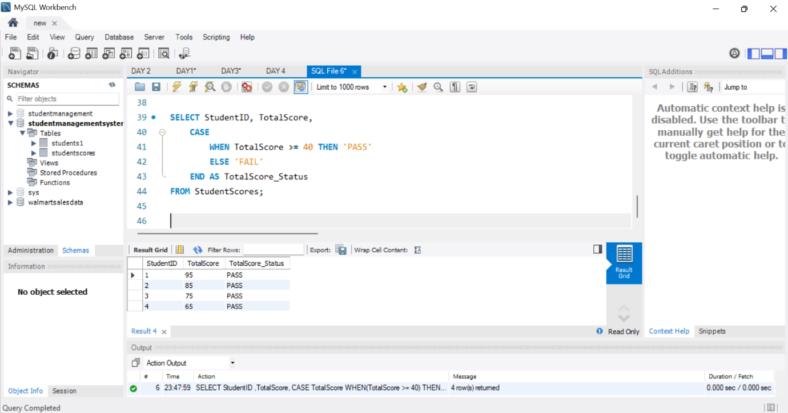

**Summary**

The project involved analysing student performance data, focusing on the distribution of grades and identifying pass/fail rates in specific subjects. The analysis revealed overall moderate performance, with most students falling into the B and C grade categories. Critical insights were gained regarding the higher failure rates in Mathematics and Science, compared to higher pass rates in English and History.

**Key Findings:**

* Majority of students achieved B and C grades.
* Higher failure rates in Mathematics and Science.
* Higher pass rates in English and History.
* Recommendation for additional support in challenging subjects.

**Main Flow Services and Technologies Pvt. Ltd.**

* Contact No.: +91 9389641586, +91 97736 99074
* Email: contact.mainflow@gmail.com
* Website: www.mainflow.in